**PXL-Digital**

Bachelor in de Elektronica-ICT

**Writing: Second draft of the webtext**

Vak: Project ontwerpen English

Docent: Eric Caers

Pablo Jenné

1. Content

I. Content 1

II. Product Description 2

III. How to Build 3

IV. Encountered Difficulties 7

V. Bill of Materials 8

1. Product Description

This project is about making a LED-matrix board. There are two goals for this project. One is based on designing a PCB, the second one is the experience you gain by making this project.

The goal is to display different road signs on the matrix. The whole project will be controlled by an Arduino, which is based on an ATmega328p chip that is programmable. Tis chip has 14 digital input/output pins, of which three are used in this project. Data-in, CLK and DIN. Further it has 6 analog pins, none of which are used, and finally +5V and ground pins. There are still two components required: an IC and the LED-matrix itself.

1. How to Build

Supplies

These supplies are required to build the project. The parts can be found on any electronic related website which sells electronic parts.

* An Arduino Uno (1x)
* IC MAX 7219 (4x)
* Resistor 27 Kohm (4x)
* Resistor 10 Kohm (4x)
* Wire jump (3x)
* SMD Capacitor 10µF (4x)
* Exteern power supply (+5V)
* PIN header 3PINS female (1x)
* PIN header 8PINS female (8x)

1. Step 1 [Schematic]

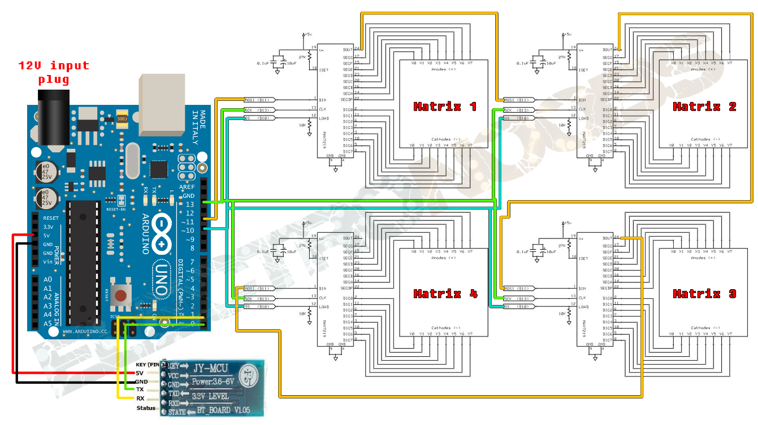

It all starts with a good schematic. It is very important to find a clear and simple schematic. In the image above the following things become clear: which components are needed, the source voltage and an obvious view how the project will look at the end.

1. Step 2 [make a BoM (Bill of Materials]

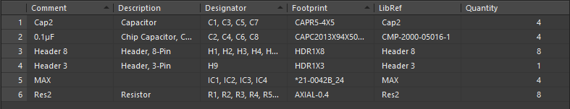

A BoM is just a list where the necessary components are listed. Due to this list it is easy to place an order with the manufacturer to buy the necessary parts. This list is generated in Altium designer.

1. Step 3 [Start drawing schematic to develop PCB]

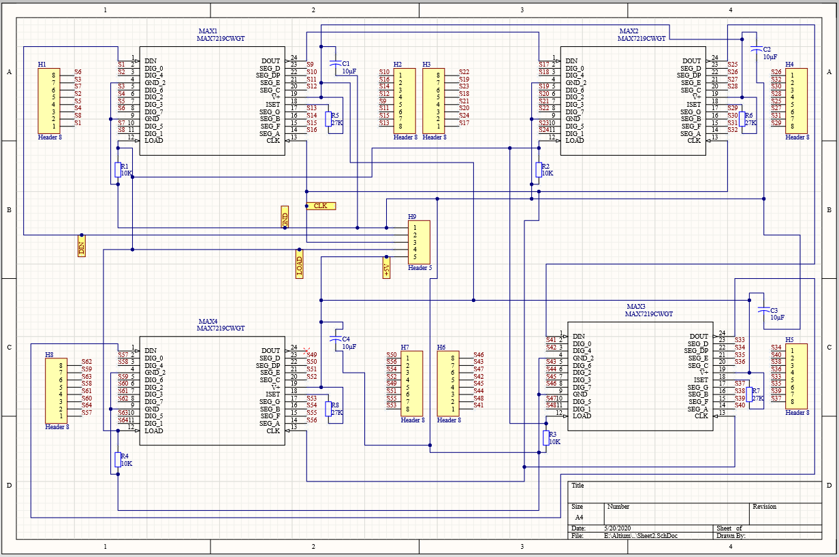

Drawing a schematic is the first step to design a PCB (printed circuit board). For this project Altium Designer is chosen as drawing software. It is not free but PXL has licenses for students. See schematic: try to avoid crossings when connecting the components in the schematic.

1. Step 4 [Start drawing PCB design]

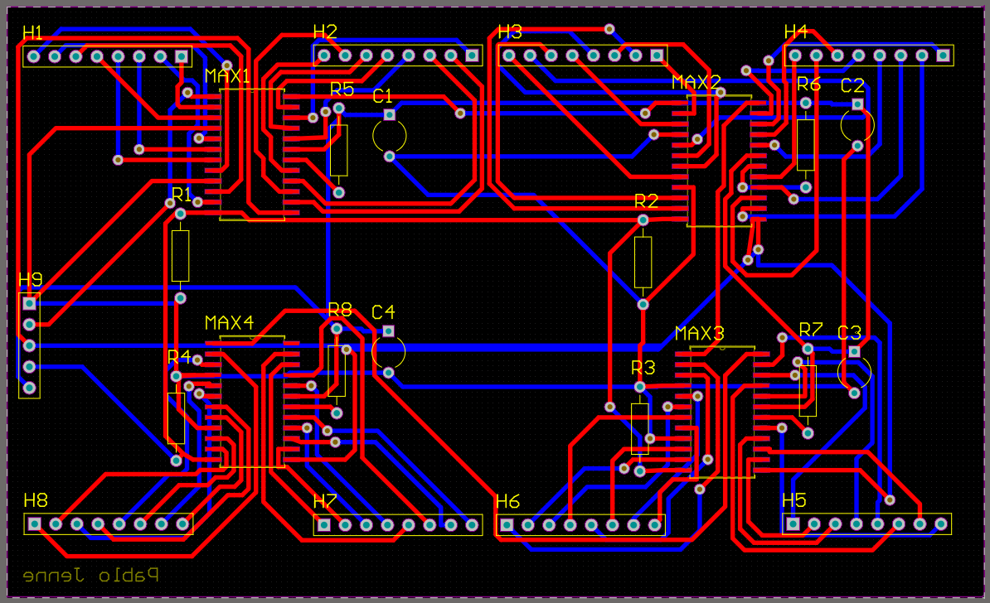

For the PCB design drag the components on the PCB. When this is done the next step is connecting them to each other just like the schematic. It is possible to connect them on two layers: the bottom layer and top layer. SMD components are mounted on the top of the print and true hold components are mounted through the print.

1. Step 5 [Assemble the components]

Start mounting the components on the PCB. When they are placed take a soldering iron and tin. Make sure the soldering iron has a temperature that is around 320 degrees. When all the components are placed and soldered it is time for the next and second last step.

1. Step 6 [Upload code]

Upload the Arduino code to display the road signs on the LED-matrix board. The code can be found on the internet. Make sure the Arduino and PC are connected to each other, otherwise it will not work. Once the code has been uploaded, it is ready to go!

1. Step 7 [Testing]

This is the last step. Provided everything is well laid out, it has to display the road signs on the LED-matrix board now.

1. Encountered Difficulties

The first problem I had was finding a related schematic, because I did not find any good schematic in the Elektor magazines. I searched the internet but most of the time you find schematics that does not meet the requirements. Eventually I found one, see Step 1.

The second big difficulty I encountered was finding the correct footprints for the components. In the beginning it was not such a big problem because I used “true hold components” but later I have changed some to SMD’s. Then a few problems started, you have to pay attention to so many things, for example: the distance between the pins, there are SMD’s IC’s with various lengths etc….

The last problem was connecting the IC’s with the headers. See picture on the left, the IC’s are connected with wires and a bus structure on the headers. On the right picture I connected them only with labels.

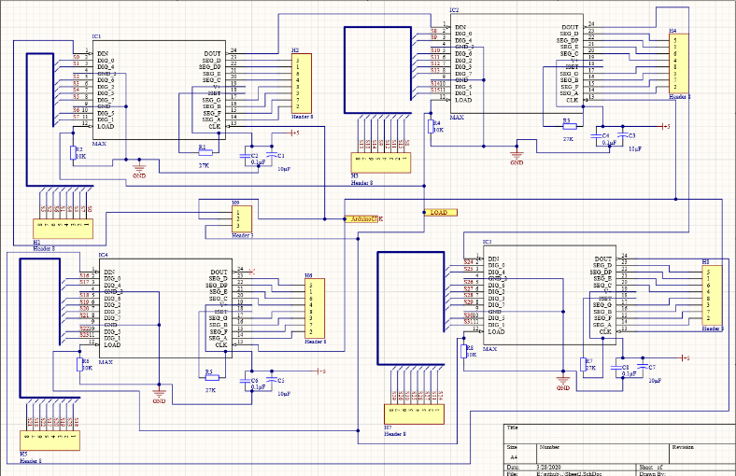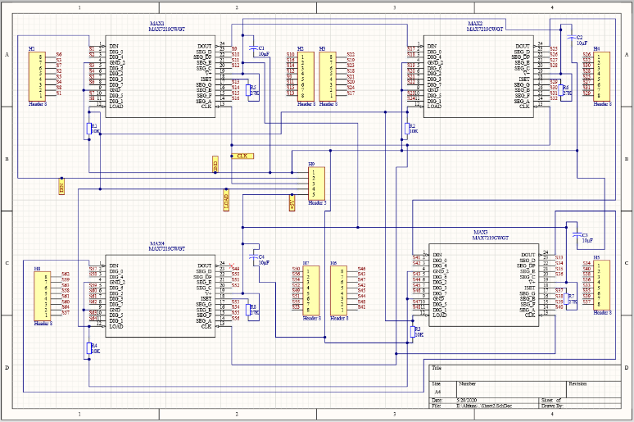

before after

1. Bill of Materials

